Jolt Step

Objective

JOLT step is used to convert the JSON input into a required specification.

UI

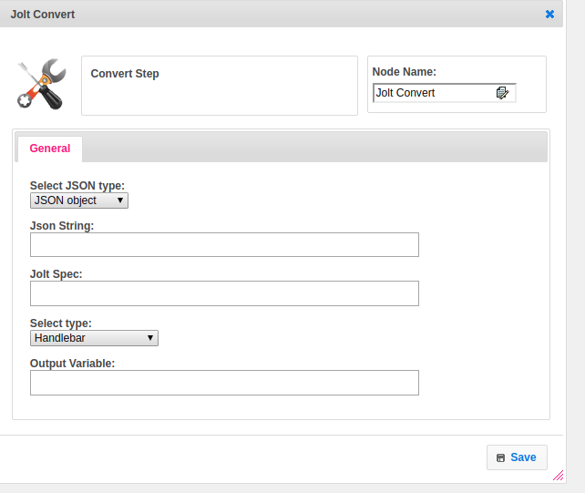

## Attributes

|  |  |
| --- | --- |
| **Attributes** | **Description** |
| **1. Select JSON Type** | Select the type of the JSON |
| **2. JSON String** | Provide JSON |
| **3. Jolt Spec** | Provide the jolt specification |
| **4. Select Type** | Select Type used to set the value type.  Value types are two types.  1.hb-HandleBars  2.ftl-Freemarker Template Language. |
| **5. Output Variable** | Used to store the response of the request. |

## Executor Description:

Converting the specification in Java List format. Taking the JSON String and converting it into a map.